1. Game DB

- DBSrv200’s Folder
  - !serverinfo
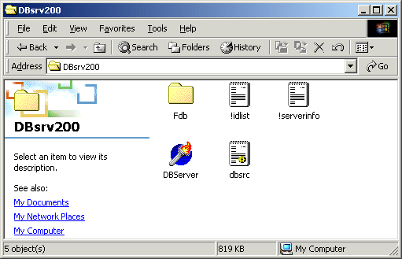

  - !serverinfo : creation of GameServer’s Connection
Login Gate Address Run Gate(1) RunGate(2) ….
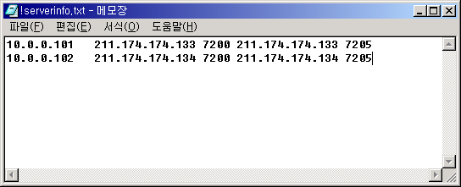
Game Gate’s Public Address Port ……..
Game Gate’s Private Address

B. dbsrc.ini
[Setup]
Port=6000
MapFile=..\Mir200\Envir\MapInfo.txt
ViewHackMsg=0
[Server]
IDSAddr = 10.0.0.250 <-DB Server IP Address
IDSPort = 5600
[DB]
dir=d:\mud2\DBsrv200\FDB\
IdDir=d:\mud2\DBsrv200\FDB\
HumDir=d:\mud2\DBsrv200\FDB\
FeeDir=d:\mud2\DBsrv200\FDB\
Backup=
connectDir=
LogDir=

*** 서버 셋트 추가시 IDSAddress 주소만 바꾸어 주어 다른 서버 셋트로 복사해 주면
됩니다. ***

